Task 1 – University Evaluation System (Abstract Class & Abstract Methods)
- Screenshot of output
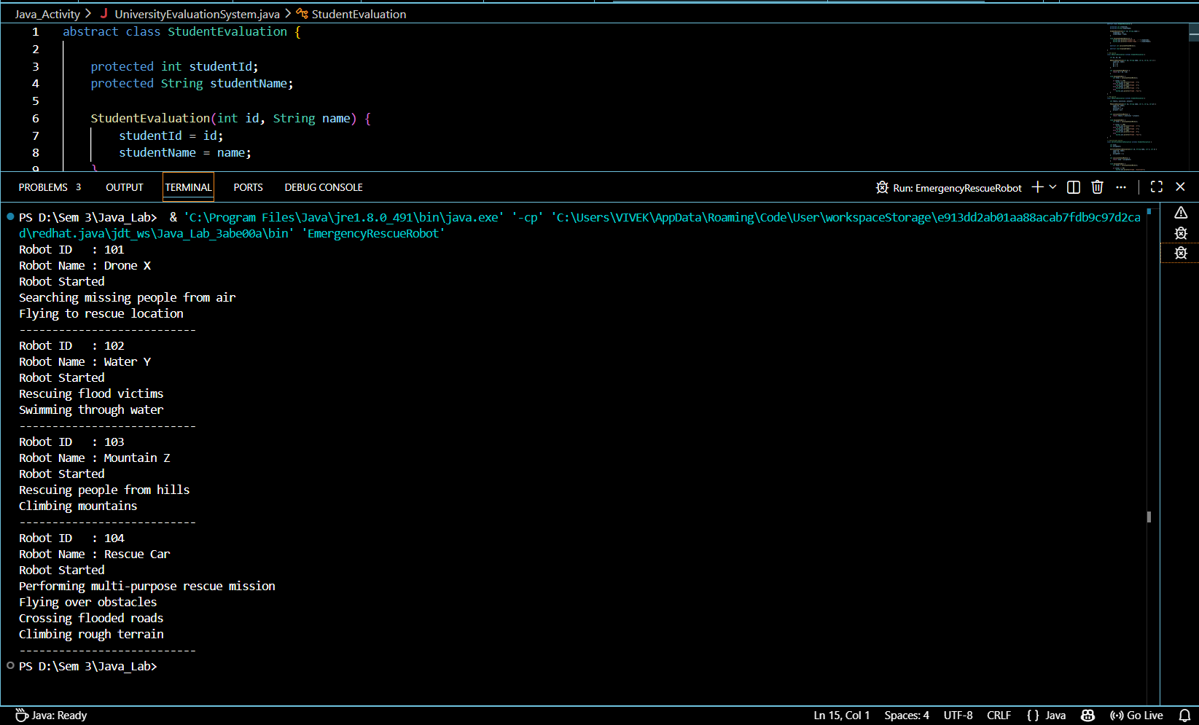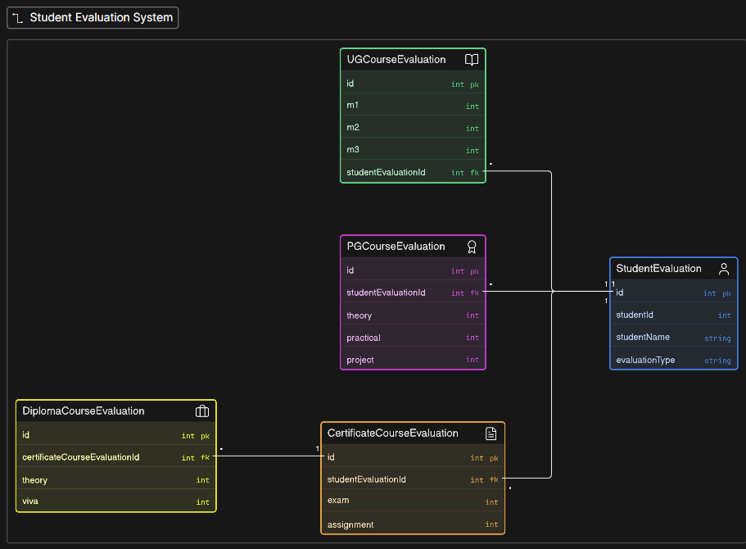
Why an Abstract Class Was Used
The StudentEvaluation class was created as an abstract class because it represents a general concept of student evaluation rather than a specific course evaluation. Every student has common information such as student ID and student name, and all course evaluations require methods to calculate total marks and display grades. These common members and methods are implemented once in the abstract class to avoid code duplication.
However, each course follows a different marking scheme. For example, UG, PG, and Certificate courses calculate marks and grades differently. Therefore, the methods calculateTotalMarks() and displayGrade() are declared as abstract methods. Every subclass must provide its own implementation of these methods, ensuring flexibility while maintaining a common structure.
Using an abstract class improves code reusability, maintainability, and runtime polymorphism. A new course type, such as DiplomaCourseEvaluation, can be added simply by extending the abstract class without modifying the existing code.
Why Interfaces Were Used
Interfaces were not used in this task because all course evaluation classes shared common data and behavior, which are better represented using an abstract class.
Where Multiple Inheritance Was Required
Multiple inheritance was not required in this program because every course evaluation class extends only one parent class, StudentEvaluation.
Can the Program Be Implemented Using Only Classes?
Yes. The program can be implemented using only normal classes. However, this would result in code duplication and would not enforce every course type to implement its own marking scheme. Using an abstract class provides a better object-oriented design by enforcing consistency and reducing repeated code.

Task 2 – Smart Device Control System
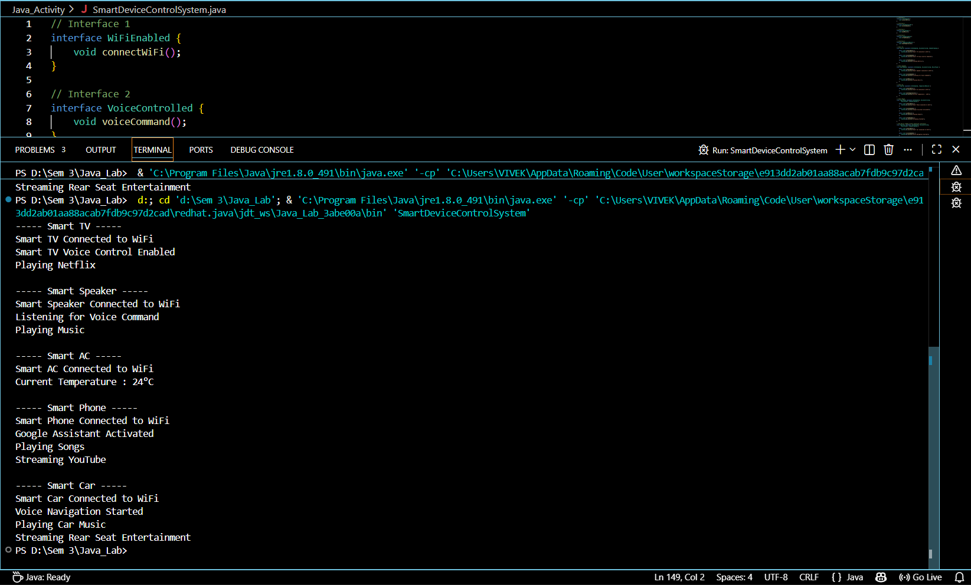
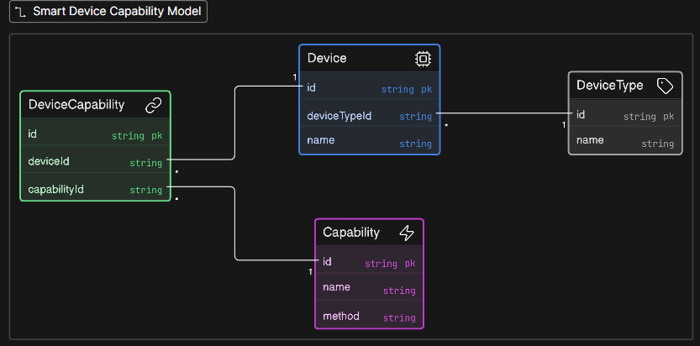
Why an Abstract Class Was Used
An abstract class was not used in this task because the devices do not share common data or implementation. Each smart device only needs to support specific features.
Why Interfaces Were Used
Interfaces such as WiFiEnabled, VoiceControlled, MusicPlayer, VideoStreaming, and TemperatureMonitor were used because they define individual capabilities of smart devices. Different devices implement only the interfaces required for their functionality. This provides flexibility, modularity, and loose coupling.
For example:
- SmartTV implements Wi-Fi, Voice Control, and Video Streaming.
- SmartSpeaker implements Wi-Fi, Voice Control, and Music Player.
- SmartAC implements Wi-Fi and Temperature Monitor.
- SmartPhone implements Wi-Fi, Voice Control, Music Player, and Video Streaming.
Where Multiple Inheritance Was Required
Java does not support multiple inheritance using classes, but it supports multiple inheritance through interfaces. This was demonstrated by the SmartCar class, which implements multiple interfaces simultaneously:
- WiFiEnabled
- VoiceControlled
- MusicPlayer
- VideoStreaming
This allows a single class to inherit multiple behaviors without ambiguity.
Can the Program Be Implemented Using Only Classes?
Yes, but it is not recommended. Using only classes would make it difficult to share independent features among different devices and would reduce flexibility. Interfaces provide a cleaner and more extensible design.

Task 3 – Emergency Rescue Robot
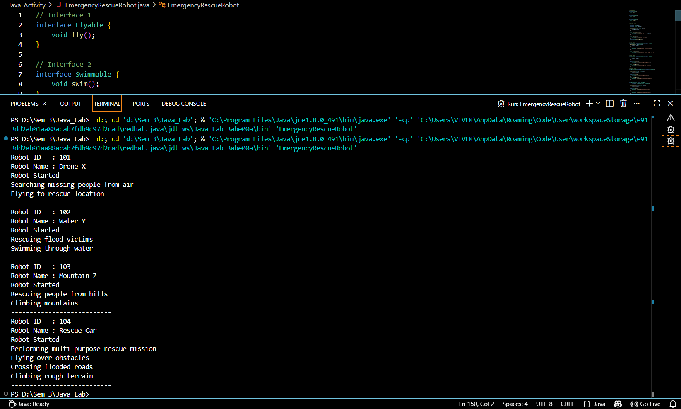
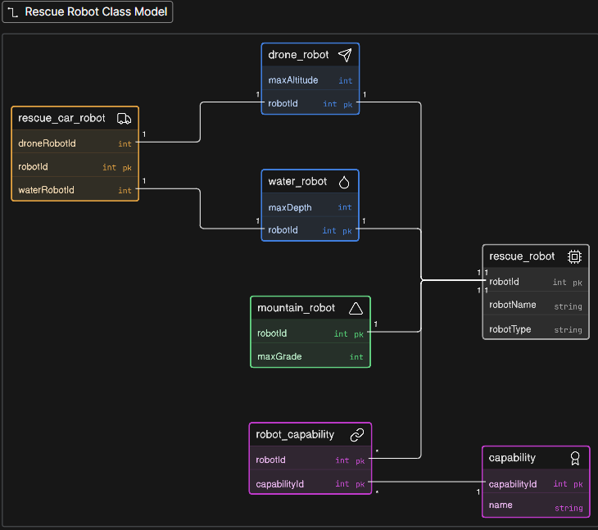

Why an Abstract Class Was Used
The RescueRobot class was designed as an abstract class because it represents a general rescue robot. All robots share common information such as robot ID and robot name, along with common methods like displaying robot details and starting the robot.
However, every robot performs its rescue mission differently. Therefore, the method performMission() was declared as an abstract method, allowing each robot class to provide its own implementation.
This design reduces code duplication, improves maintainability, and supports runtime polymorphism through abstract class references.
Why Interfaces Were Used
Interfaces Flyable, Swimmable, and Climbable were used because different robots possess different capabilities. Some robots can fly, some can swim, while others can climb. Interfaces allow each robot to implement only the required abilities without forcing unnecessary methods.
Where Multiple Inheritance Was Required
Multiple inheritance was achieved using interfaces. For example, the RescueCarRobot class extends the abstract class RescueRobot while implementing the interfaces Flyable, Swimmable, and Climbable. This enables the robot to perform multiple specialized operations while still inheriting common properties from the abstract class.
Can the Program Be Implemented Using Only Classes?
Yes. The program can be implemented using only classes, but it would reduce flexibility and increase code duplication. Features such as flying, swimming, and climbing would need to be repeated or inherited through a rigid class hierarchy. Using interfaces provides a better design by allowing different robot classes to combine capabilities as needed while keeping the program modular and extensible.

